SIMATSENGINEERING
ASSESSMENTTOOL1

Experiments

COURSENAME:Computer Networks COURSECODE: CSA07

COURSEOUTCOMECOVERED

CO3:AnalyzetheperformanceofcorenetworkprotocolssuchasTCP,UDP,HTTP,and DNS under varying conditions
AssessmentToolWeightage:40%
SOFTWARE:CISCOPACKETTRACER, WIRESHARK

EXPERIMENTS

QUESTIONS:4 TotalMarks:40

- Design a simple LAN consisting of two PCs connected through a switch using CiscoPacketTracer.ConfigureappropriateIPaddressesforbothhostsandverify connectivity using the ping command. Simultaneously capture the packet exchange using Wireshark. Identify the Ethernet frame fields such as Source MAC Address, Destination MAC Address, EtherType, and Frame Check Sequence(FCS).ExplainhowtheDataLinklayerusesMACaddressingtoensure successful frame delivery within the local network.
- CreateanetworktopologyconsistingoftwoLANsconnectedthrougharouterin Cisco Packet Tracer. Configure IPv4 addressing, subnet masks, and default gateways for all devices, and verify end-to-end communication using the ping command. Capture the ICMP packets using Wireshark and analyze the IPv4 header fields, including Source IP Address, Destination IP Address, Time-To-Live (TTL), Protocol Number, and Header Length. Explain the role of the Network layer in forwarding packets between different networks.
- Constructalocalareanetworkwithmultiplehostsconnectedthroughaswitchin Cisco Packet Tracer. Clear the ARP cache on one of the hosts and initiate communication with another host using the ping command. Capture the communication in Wireshark and identify the ARP Request and ARP Reply packets. Analyze the sender and target MAC/IP addresses and explain how the Address Resolution Protocol resolves logical IP addresses into physical MAC addresses before data transmission.
- Develop a simple network consisting of two PCs connected through a router in Cisco Packet Tracer. Configure the required IP addresses and test connectivity usingthe ping command. CapturetheICMP trafficusing Wireshark and identify the Echo Request and Echo Reply messages. Examine important ICMP fields such as Type, Code, Identifier, and Sequence Number, and calculate the Round Trip Time (RTT). Discuss how ICMP assists in network troubleshooting and connectivity verification.

- Createaclient-servernetworkinCiscoPacketTracerbyconfiguringawebserver and a client PC. Enable the HTTP service on the server and access the hosted webpage from the client using a web browser. Capture the communication in Wireshark and identify the TCP three-way handshake, followed by the HTTP GET request and HTTP response messages. Analyze the application-layer communicationandexplainhowTCPprovidesreliabledeliveryforHTTPtraffic through connection establishment, acknowledgments, and ordered data transfer.
RUBRICSFORCALCULATION

Criteria | Weightag e | Level 4 – Exemplary | Level 3 – Proficient | Level 2 – Developing | Level 1 – Beginning
Understandin g of Concepts | 25 | Demonstrates thorough understanding and effectively integrates multiple  concepts/technologi es | Good understanding with proper integration of mostconcepts | Basic understanding  ;limitedor partial integration | Poor understanding  ;unableto integrate concepts
Experimental Design | 30 | Well-planned, systematic implementation with optimal solution | Correct implementati onwithminor issues | Basic implementati onwitherrors or inefficiencies | Incorrect or incomplete implementati on
Useof Tools | 20 | Effective and advanced use of tools/technologies with proper configuration | Appropriate use of tools withcorrect execution | Limited or inconsistent use of tools | Incorrect or minimaluse of tools
Analysisof Results | 15 | Insightful analysis with accurate interpretation and validationofresults | Good analysiswith reasonable interpretation | Basic analysiswith limited insights | Poor or incorrect analysisof results
Documentati on | 10 | Clear, well-structured documentationwith diagrams,code,and results | Organized documentatio n with necessary details | Basic documentatio n with missing details | Poor or incomplete documentatio n

2. CreateanetworktopologyconsistingoftwoLANsconnectedthrougharouterin Cisco Packet Tracer. Configure IPv4 addressing, subnet masks, and default gateways for all devices, and verify end-to-end communication using the ping command. Capture the ICMP packets using Wireshark and analyze the IPv4 header fields, including Source IP Address, Destination IP Address, Time-To-Live (TTL), Protocol Number, and Header Length. Explain the role of the Network layer in forwarding packets between different networks

Aim
To create two LANs connected through a router using Cisco Packet Tracer, configure IPv4 addresses, verify end-to-end connectivity using the ping command, and analyze the IPv4 header of ICMP packets using Wireshark.

Procedure

- Create the network topology with 2 PCs, 2 switches, and 1 router.

- Connect the devices as:
PC0 → Switch0 → Router0 → Switch1 → PC1

- Configure the IP address of PC0 as:
IP: 192.168.1.10
Subnet Mask: 255.255.255.0
Default Gateway: 192.168.1.1

- Configure PC1 as:
IP: 192.168.2.10
Subnet Mask: 255.255.255.0
Default Gateway: 192.168.2.1

- Configure Router0:
FastEthernet0/0 → 192.168.1.1
FastEthernet1/0 → 192.168.2.1
Enable both interfaces using no shutdown.

- Verify connectivity by executing:
ping 192.168.2.10
from PC0.

- Capture the ICMP packets in Wireshark and examine the IPv4 header fields.

In Cisco Packet Tracer :

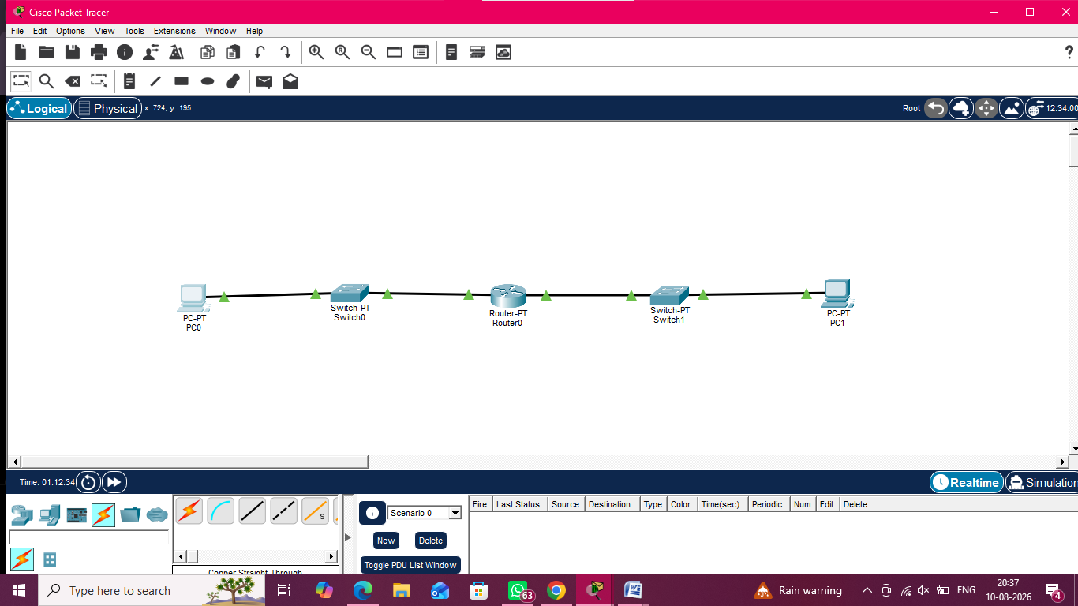

Figure 1: Network topology created in Cisco Packet Tracer.
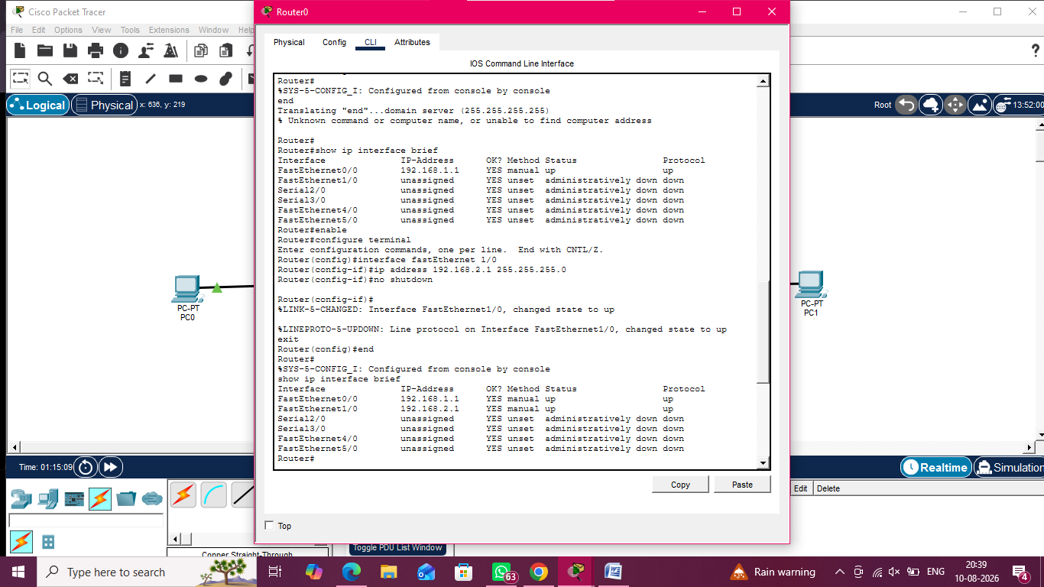

Figure 2: Router interface configuration and status.

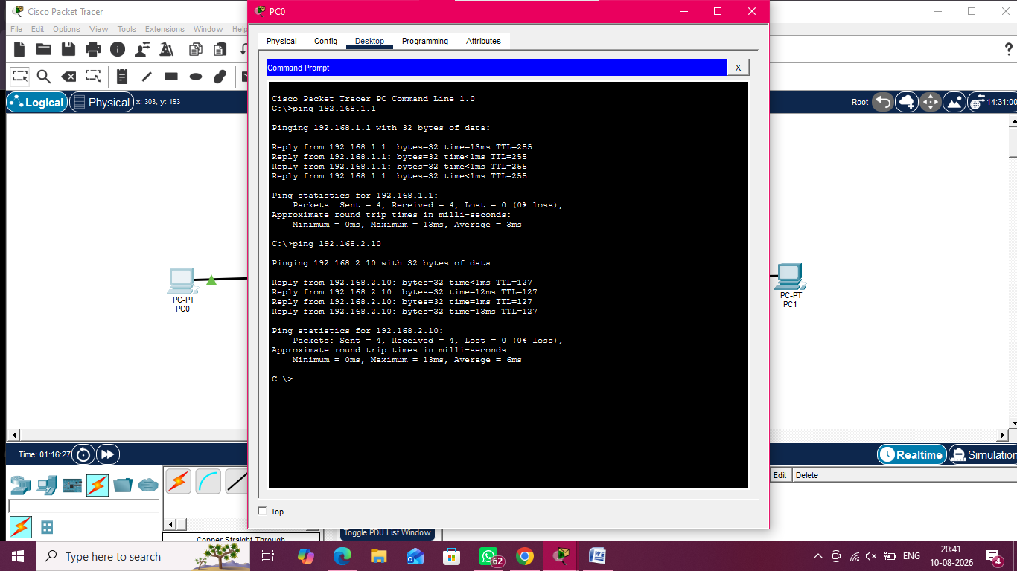

Figure 3: Successful communication between the two LANs using ping.

In Wireshark

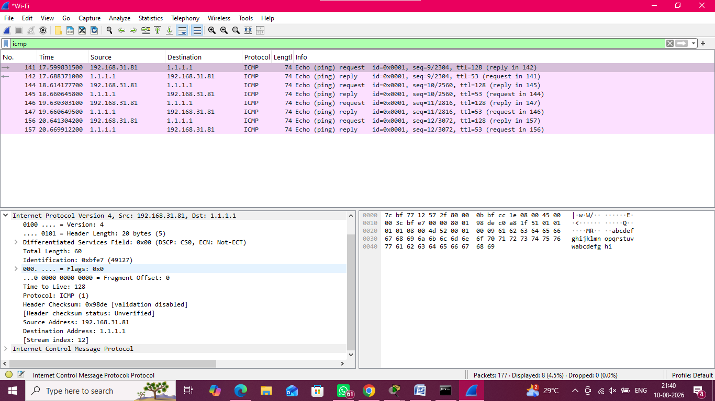

Figure: ICMP Packet Capture and IPv4 Header Analysis using Wireshark

Result

Thus, two LANs were successfully connected through a router using Cisco Packet Tracer. IPv4 addressing and default gateways were configured, and end-to-end connectivity was successfully verified using the ping command. The ICMP packets were captured using Wireshark and the required IPv4 header fields were analyzed successfully

- Develop a simple network consisting of two PCs connected through a router in Cisco Packet Tracer. Configure the required IP addresses and test connectivity usingthe ping command. CapturetheICMP trafficusing Wireshark and identify the Echo Request and Echo Reply messages. Examine important ICMP fields such as Type, Code, Identifier, and Sequence Number, and calculate the Round Trip Time (RTT). Discuss how ICMP assists in network troubleshooting and connectivity verification.
Aim

To establish a network of two PCs connected through a router using Cisco Packet Tracer, configure IP addresses, verify connectivity using the ping command, and analyze ICMP packets using Wireshark.

Procedure

- Create a network topology consisting of two PCs, two switches, and a Cisco 1841 router, and connect them using appropriate cables.
- Configure IPv4 addresses and default gateways for both PCs and configure the router interfaces.
- Verify the router interfaces and test connectivity between the PCs using the ping command.
- Capture the ICMP traffic using Wireshark while performing the ping operation.
- Identify the ICMP Echo Request and Echo Reply packets and examine their Type, Code, Identifier, and Sequence Number fields.
- Calculate the Round Trip Time (RTT) using the timestamps of the corresponding Echo Request and Echo Reply packets.

In Cisco Packet Tracer

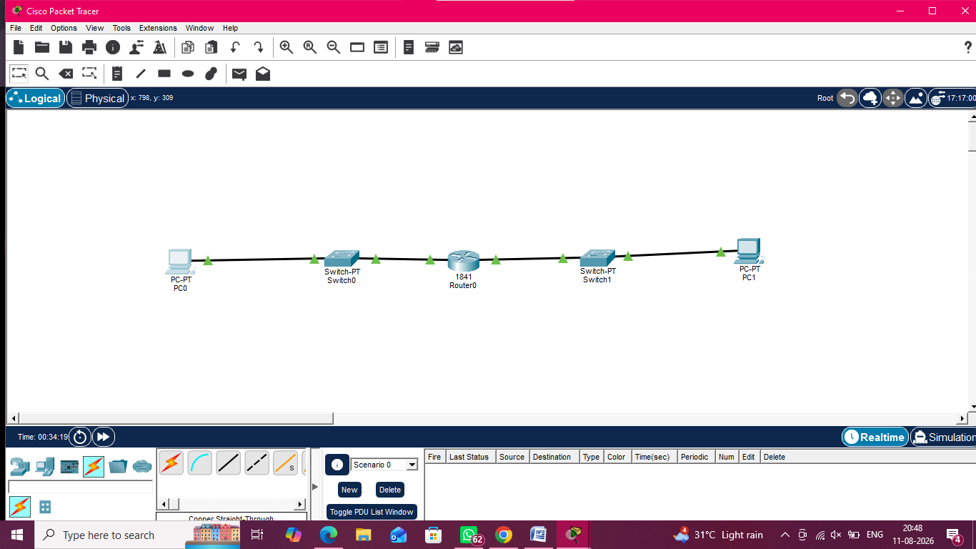

Figure 1: Configured Network Topology

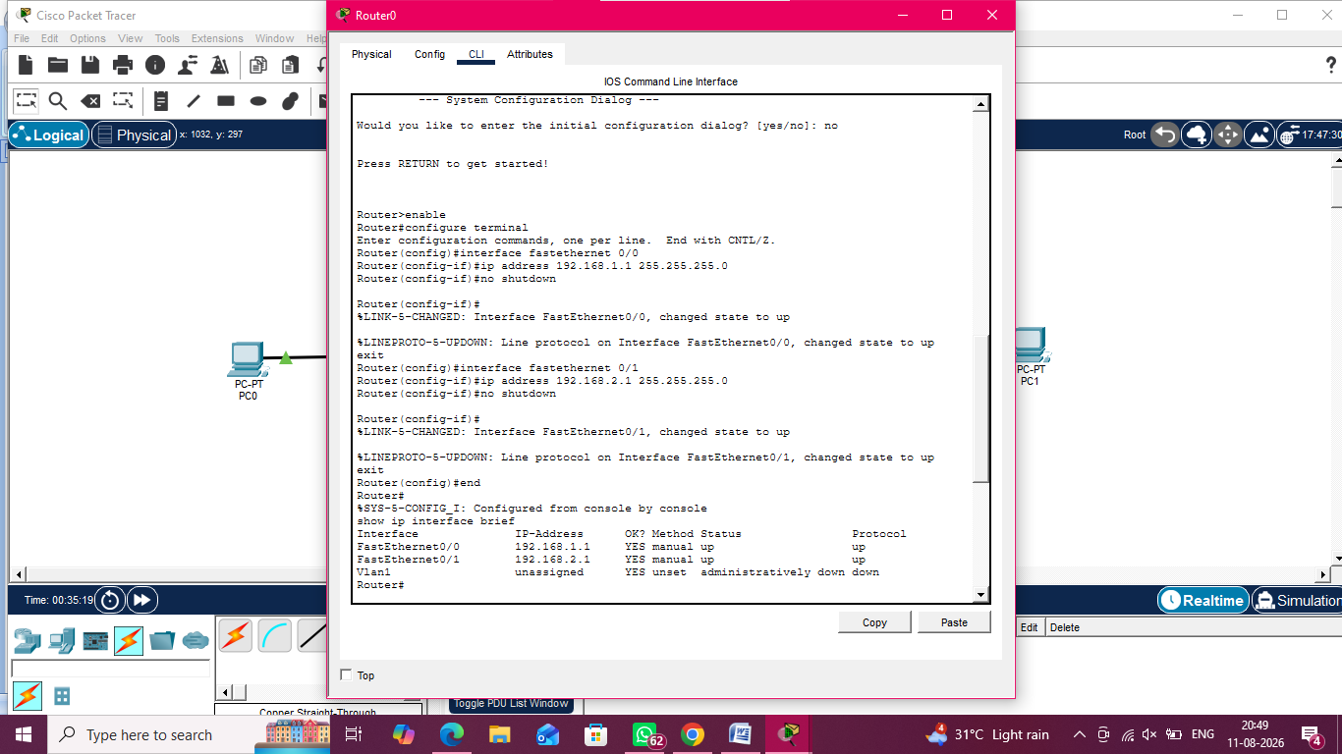

Figure 2: Router Interface Configuration and Status

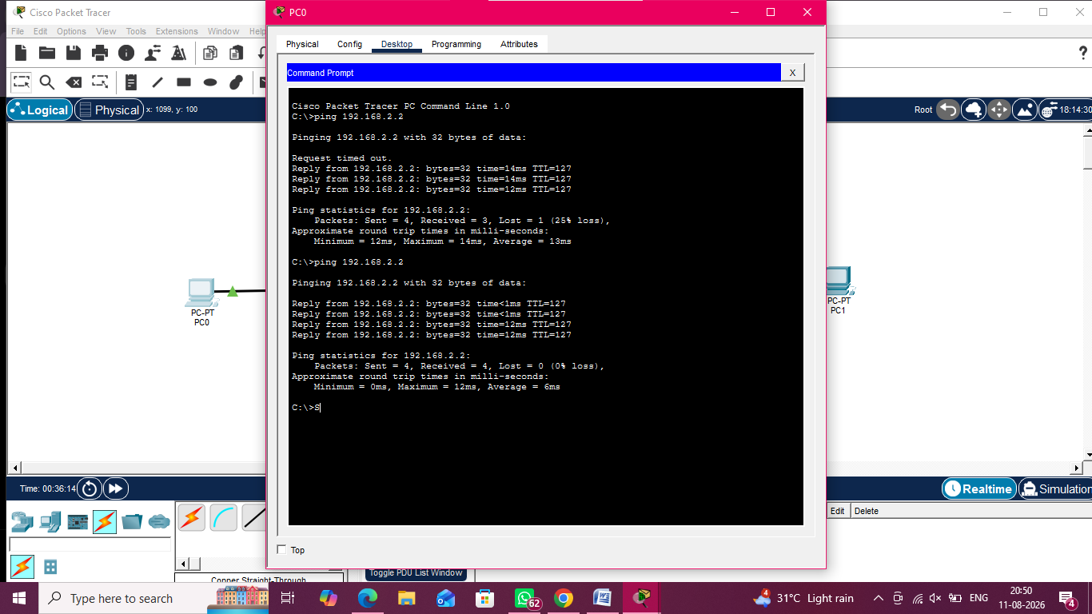

Figure 3: Connectivity Verification Using Ping

In Wireshark

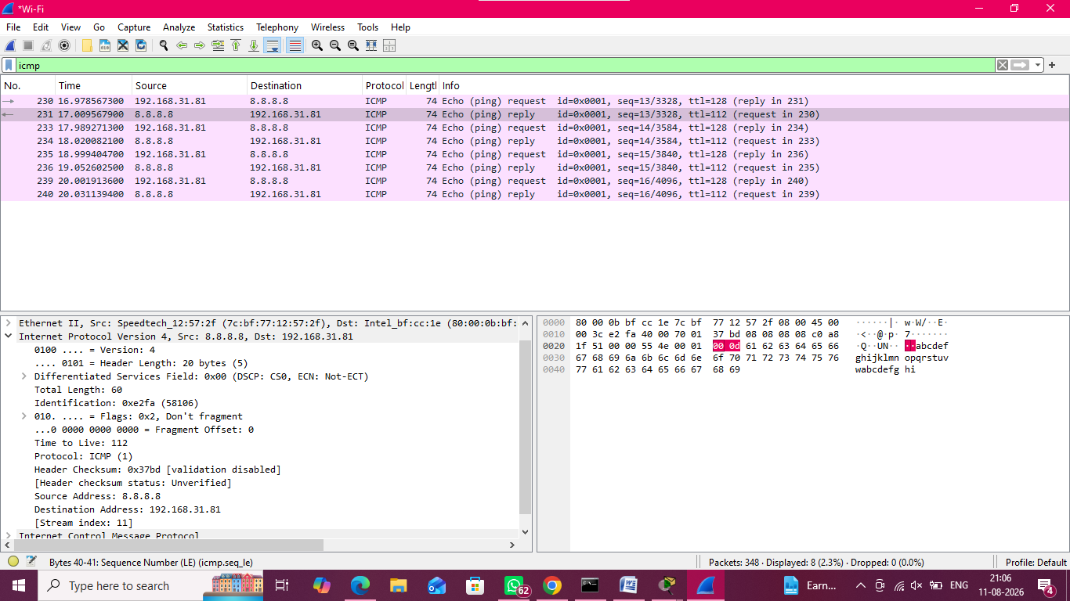

Figure 4: ICMP Echo Request and Echo Reply Analysis Using Wireshark

Result

The network was successfully configured using Cisco Packet Tracer, and connectivity between the two PCs was verified using the ping command. ICMP Echo Request and Echo Reply packets were captured and analyzed using Wireshark. The ICMP Type, Code, Identifier, Sequence Number, and Round Trip Time (RTT) were successfully identified. ICMP was found to be useful for verifying network connectivity and troubleshooting communication problems.

